CSA1509-Cloud computing and big data analytics
Experiment-7
Create a simple cloud software application for Students Attendance System using any Cloud Service Provider to demonstrate SaaS include the necessary fields such as name of the students, course, present, Absent, course attendance, OD request, grade, attendance percentage, etc.
Input:
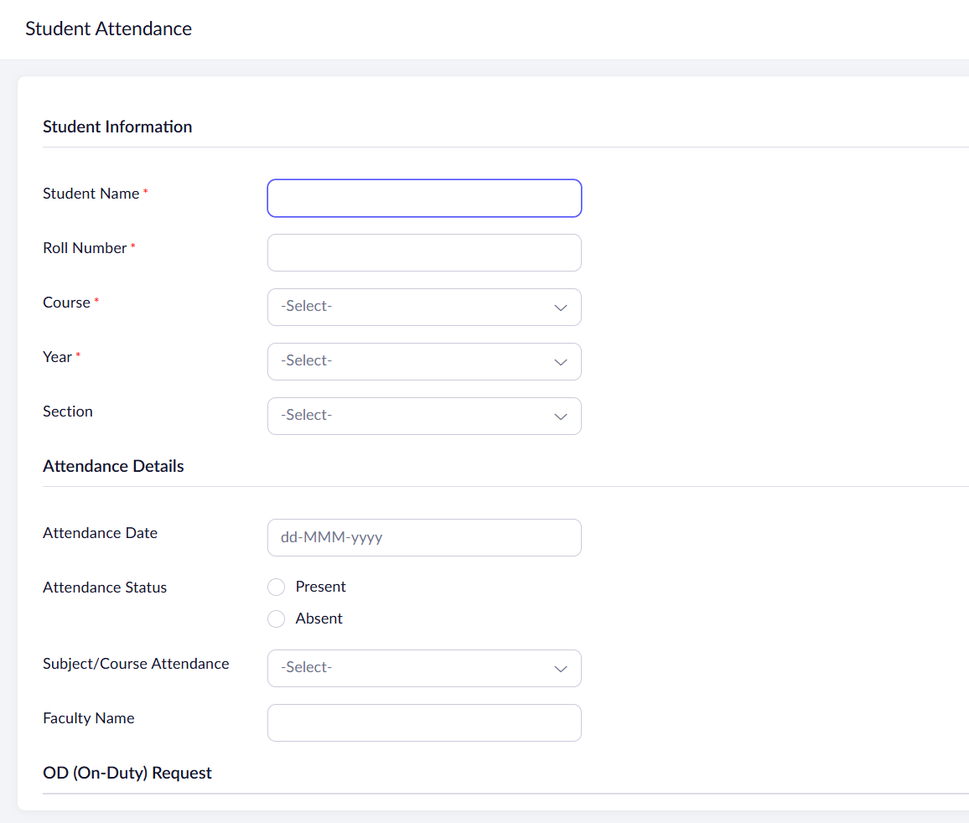
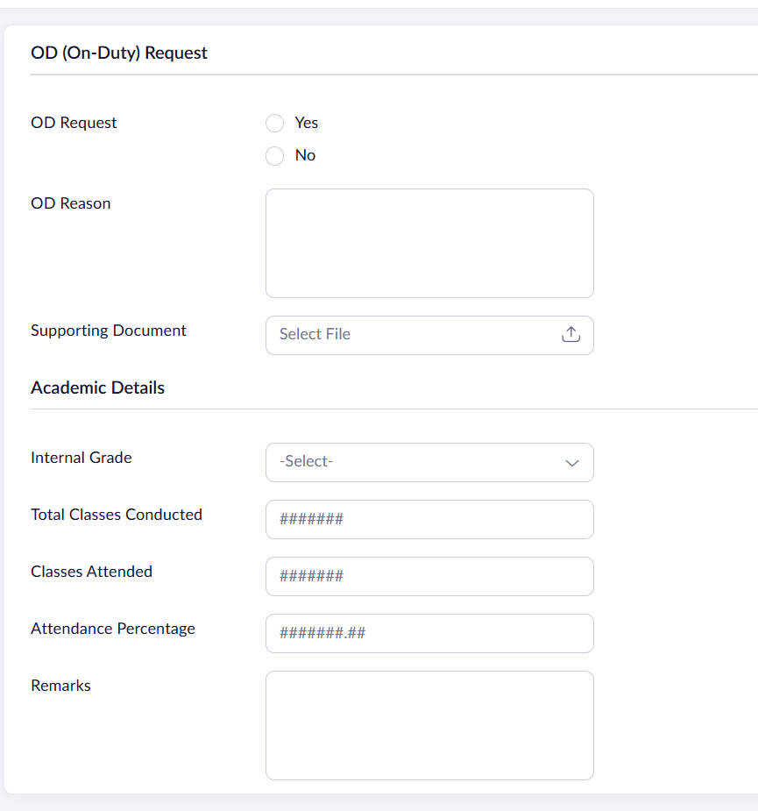

Output:
